ECG Classification
Introduction:
Time series classification can be treated as a supervised learning problem. From this
perspective, aforementioned common issues related to time series analysis correspond to a
feature extraction step and an appropriate classification approach.

This paper¹ uses a parametric integral dynamic time warping distance measure ID_{DTW} which is a parametric combination of the distances Dynamic Time Warping (DTW) and IDTW as the feature extractor. And using well-known nearest neighbor (1NN) as the classifier. They didn’t specify train and test size. Maybe the default size. The test error rates are shown below.
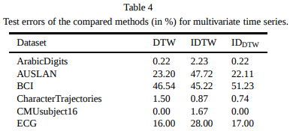
This paper² uses Symbolic Aggregate ApproXimation technique(SAX) as preprocessing step to discretize the time series and uses recurring subsequences (“motifs”) as features. 100 for training, 100 for test. The error rate they acquired are shown below.
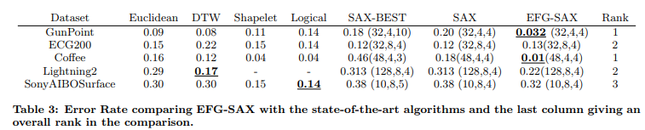
This paper³ utilizes feature covariance matrices to describe time series. And 1NN classifier is utilized. 100 for training, 100 for test. CovNN and CovSVM for the union of the covariance representation with 1-NN and SVM classifiers. Error rates they got are shown below.
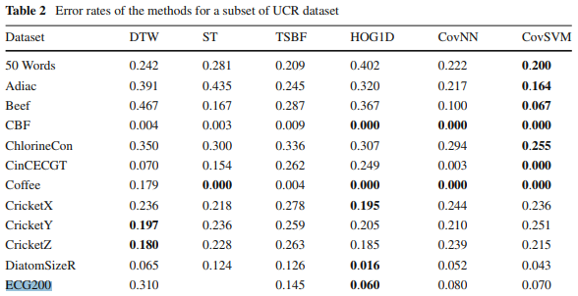
The paper5 uses HOG-1D+DTWMDS as descriptor, SVM as classifier. K, α are obtained by 15-folder cross-validation on training data. The error rate (0.060) they got on ECG200 is listed above.

This paper⁴ uses TimeNet as a feature extractor, SVM with RBF kernel as a classifier. On ECG5000, their error rates are shown below. They didn’t train on ECG5000, but just have a test on them.
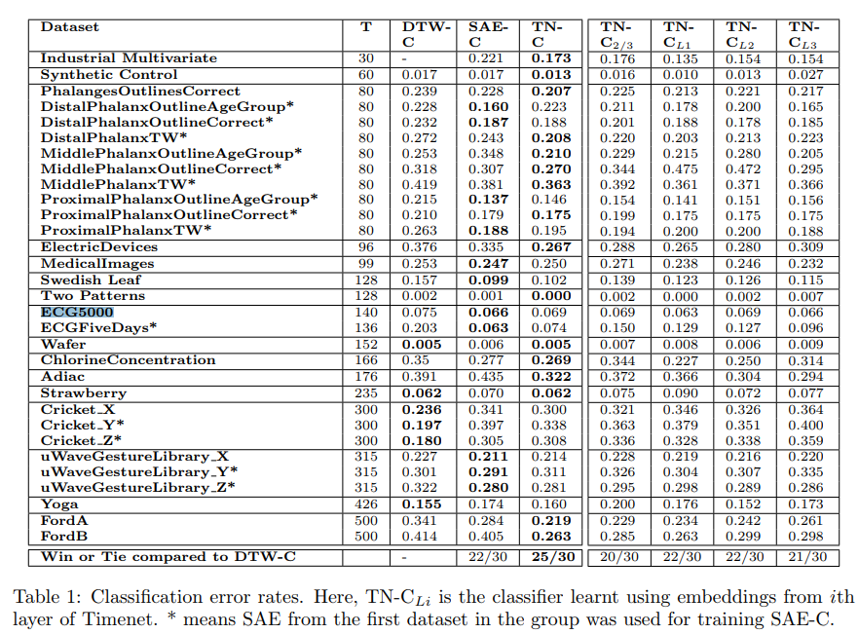

[1] M. Łuczak, Univariate and multivariate time series classification with parametric integral dynamic time warping, Journal of Intelligent & Fuzzy Systems 33(4) 2017, 2403–2413.
[2] SAX-EFG: an evolutionary feature generation framework for time series classification, 2014
[3] Time series classification with feature covariance matrices, 2017
[4] TimeNet: Pre-trained deep recurrent neural network for time series classification, 2017
[5] J. Zhao and L. Itti, "Classifying Time Series Using Local Descriptors with Hybrid Sampling," in IEEE Transactions on Knowledge & Data Engineering, vol. 28, no. 3, pp. 623-637, 2016.

